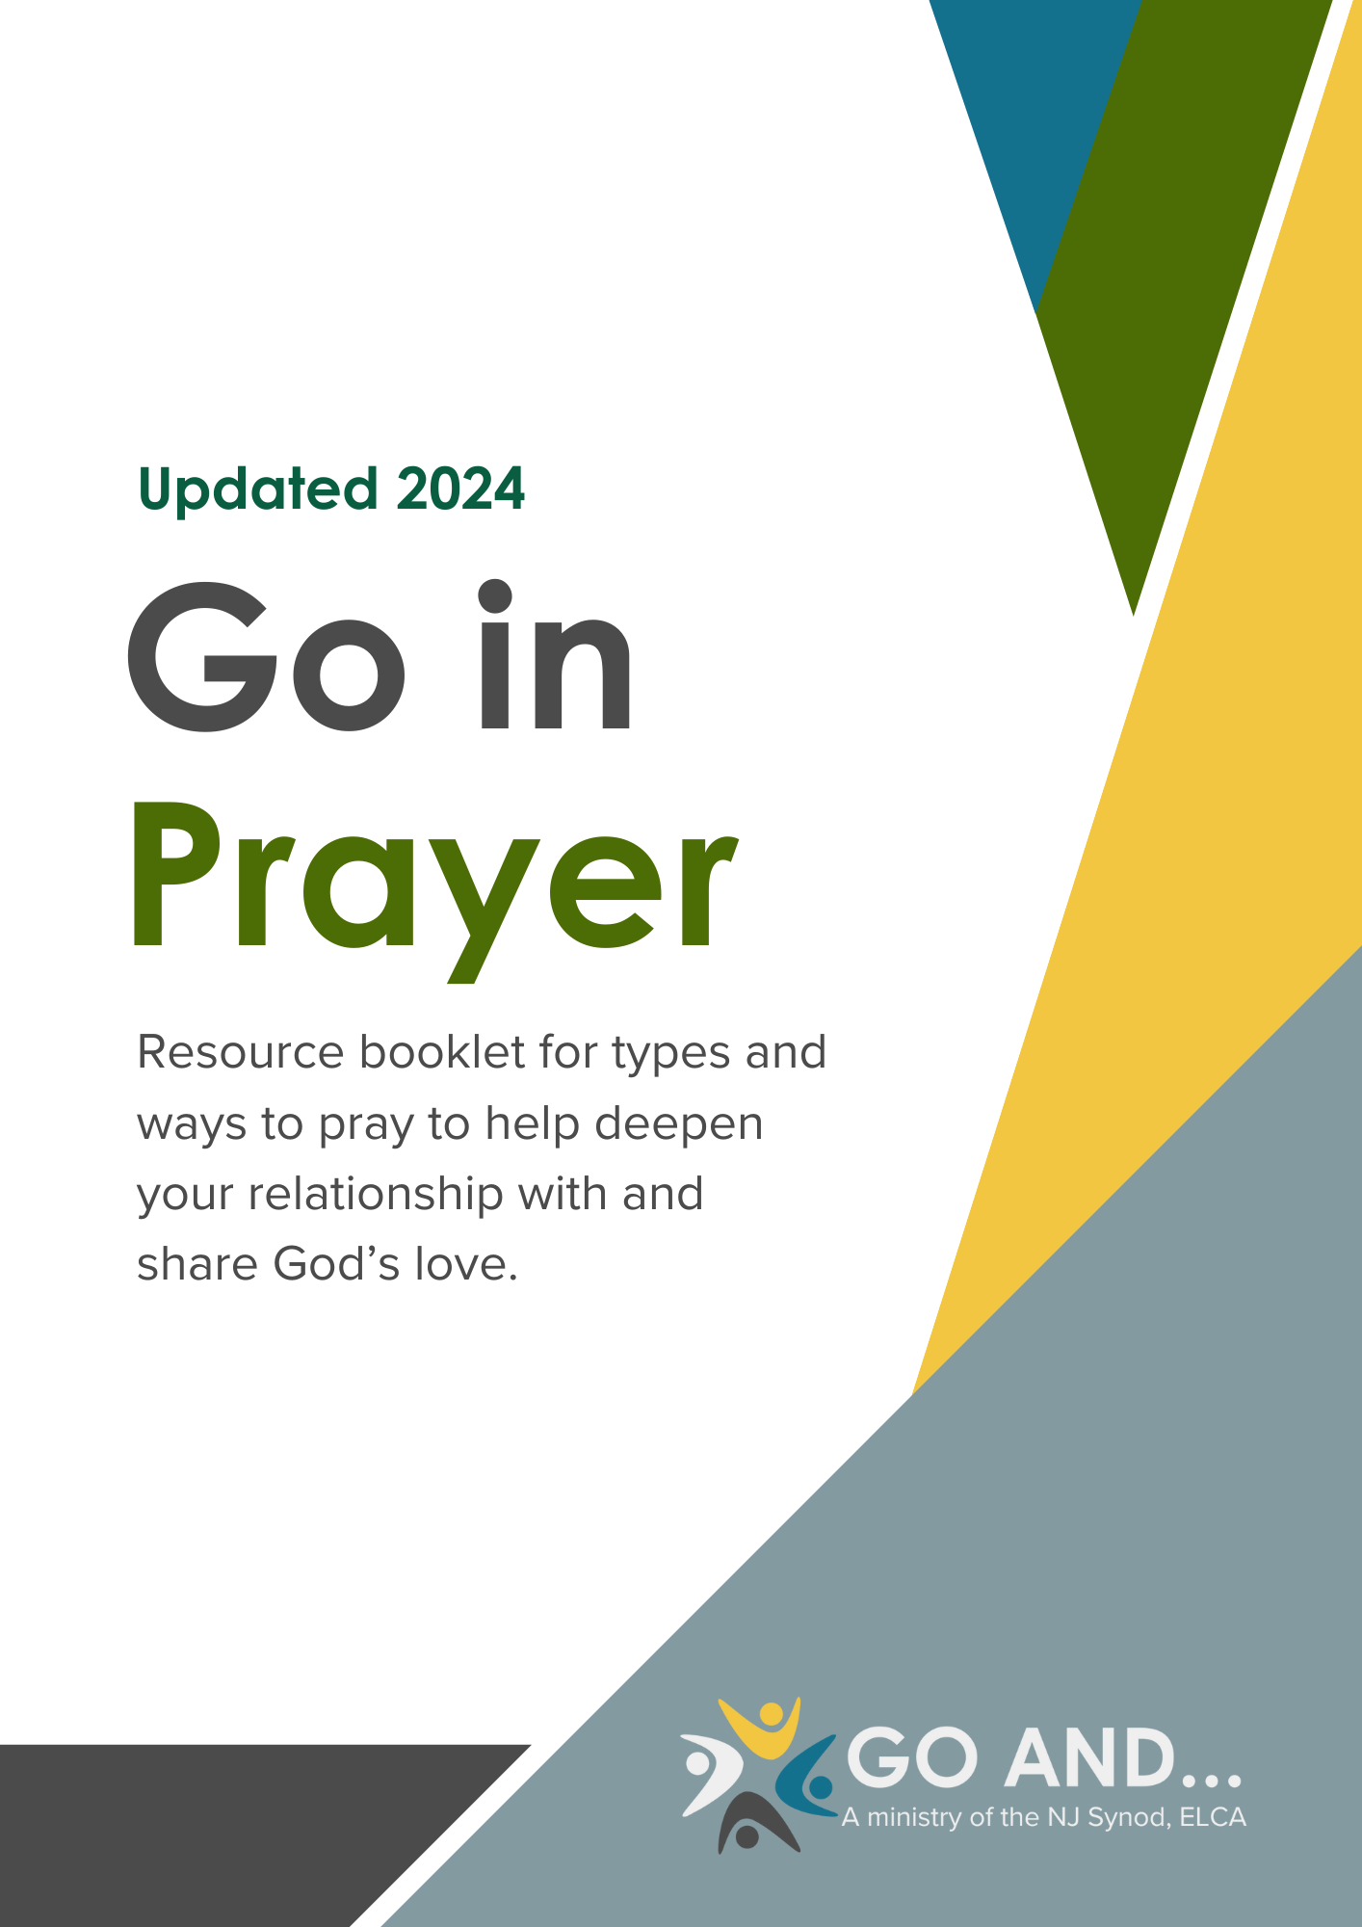

Prayer Changes Lives

To engage in the practice of evangelism, to invite others into relationship with God and into Christian community, we must first grow in our own relationship with and understanding of God’s love. Prayer is one of the many ways to grow closer to God.

“To be a Christian without prayer is no more possible than to be alive without breathing.”
- Martin Luther

“God can handle your doubt, anger, fear, grief, confusion, and questions. You can bring everything to [God] in prayer.”
- Rick Warren

“All these practices start with the understanding that the Living God is already active in our lives and contexts. We engage in discerning how God is inviting us into prayer, imagination and experiments. We garden, walk, etc. and pay attention to see with God’s eyes. Feel God’s love for the place, the growing things, the people. We walk and bless the houses, or rooms, paths, and people and creatures. And pray for God’s healing, guidance, protection.”
- Pastor Maristela Freiberg, Director of Evangelical Mission, NJ Synod

We give thanks to the Go And…! planning team and participants who contributed towards this resource booklet.

Be Quiet
Prayer is a conversation: we talk to God but we also we need to listen for God. Getting away from distractions and allowing for silence is important. As you listen don’t expect to hear a voice, but look for God to tug at your heart, move your conscience, or help you to realize something you need to change in your life.

Daily Anointing Prayer
Start your day in prayer by anointing yourself with water from the shower, while brushing your teeth or doing the dishes. Invoke the Trinity using names comfortable to you such as: Father, Son, Holy Spirit; Maker, Pain Bearer, Life Giver; Creator, Redeemer, Sustainer. Talk to God with the following petitions:
- Give thanks that you are here to journey through another day.
- Ask God to forgive the wrong you have done and to help you to be a better person than you were the day before.
- Ask God to remove your pain, sorrow, procrastination; anything that keeps you from living according to God’s will

Pray Your Calendar or Schedule
Look at your daily, weekly, or monthly calendar/schedule and ask God for strength to help you through it. Pray for those with whom you will interact with and for any specific meetings, tests, or appointments.

Prayer Journal
Keep a special journal where you write your questions, struggles, and praises to God. Consider reading your entries every week or month and see how God has shown up in your life through it all.
Daily Morning Prayer
Start your morning with a time for devotion. Open your Bible to a favorite text, randomly select something to read, or choose a daily devotional. Dwell in the message, let it seep through your mind, and ask God for understanding and wisdom as you begin your day. After you are finished send a text to a friend or friends sharing the scripture and a short message of God’s divine word.

For more structure, look in Evangelical Lutheran Worship for services of Morning Prayer (Matins), Evening Prayer (Vespers), and Night Prayer (Compline) that can be done on your own or in a group.

Five Finger Prayer
Look at your hand and pray with each finger:
- Thumb: pray for those closes to you (family and friends)
- Pointer Finger: pray for those who point you in the right direction (teachers, counselors, therapists, leaders)
- Middle Finger (tallest): Pray for those that lead us (government, business, church, anyone in a position of leadership or power)
- Ring Finger (weakest): Pray for those who are poor, sick, in pain, in trouble, those most in need
- Pinkie Finger (smallest): Pray for yourself and your own needs

Prayer Cube (bought or homemade)
This is great to do with kids because it’s a bit of a game. Roll the cube and say the prayer that is on it. You can also purchase these online or make your own with prayer prompts or seasonal (themes advent, meals, bedtime).

Praying the News
When listening to, watching, or reading the news, pray for what is reported. Pray for the people involved in disasters, warfare, or troubling events, pray for the leaders and politicians, and pray for all those experiencing troubles who are neglected from the news. Give thanks to God and pray for the good happening amidst the trouble.

Praying with Our Bodies
There are many different ways to pray with our total body which is an experience of heart, mind, soul, and strength: Stretching (physically and spiritually), Yoga, Gardening, Walking, Hiking, or Swimming.
Prayer Labyrinth
Engage in the ancient practice of walking a prayer labyrinth. Embody a posture of prayer and meditation as you allow yourself to be open and vulnerable with God. If a walking labyrinth is not available, you can try using a finger labyrinth like the one below. Trace the path with your dominant finger while thinking about who/what you want to pray for or for more of a challenge, use your pinky finger and pray for weaknesses and places that need extra care.

Praying Out LOUD
If you feel comfortable doing so, stand outside and shout or scream your prayers to God. This can be especially therapeutic when you are in a tough situation.

Prayer Wall
Build a prayer wall in the church or narthex. Invite people to write prayers on the wall (visible to all) or tuck prayers into folders or slots in the wall (to keep them private). You can use this as an opportunity to talk about the Western Wall in Jerusalem and how that is a place of prayer for our Jewish siblings.

Paper Chain
You can do this with prayer requests or even with God Moments (places you’ve seen God in your life and the world).

Provide strips of different colored paper and invite people to write on the paper to add it to the paper chain. Hang the paper chain as a visible reminder that we prayers connect us together with God.

Praying with our Cameras
Invite people to take or bring photos of things for which they would like to pray. This allows an opportunity to add visuals to our prayers whether people, places, things, photos off our phone or photos from the news that connects our daily life to our prayer life.
Praying the Small Catechism through Pictures
Using the explanations from Luther’s Small Catechism, invite people to pay attention during the week for images or symbols that represent The Lord’s Prayer, the 10 Commandments, the Creeds, etc. and how they see them “breaking into” their life and the world. Collect all the photos and find a unique way to display or incorporate them into prayers and conversation.
Visio Divina – Praying with Artwork
Through this prayer practice you are invited to experience God through artwork, photos, or images. Pick the image you want to pray with, look at it and follow these steps:
- Notice the visual qualities of the image: colors, lines, shapes, forms, space, texture
- What stood out to you from this image? How would you describe this image?
- Look deeper at the image, what are your eyes drawn to? What is something you notice now that you glanced over before?
- Imagine yourself in the image. Where would you be? How would you interact with what surrounds you?
- What stories from the Bible or your own life do you associate with this image?
- How does this image make you feel or what emotions does it bring up?
- What do you think God is inviting you to pray for?

The Lord’s Prayer
Invite people to pray the Lord’s Prayer while they washed their hands. This should take about 20 to 30 seconds. If you feel comfortable, share a video of this practice on social media at a specific time in the day to help share the Lord’s Prayer with others or invite people to join you in the practice.

Devotional Prayer Books and Websites
There are many different prayer books, some with pictures, some with prayers, some with narratives to go with them. Here are some to try on your own or in a group:
- Kate Bowler: The Lives We Actually Have (2023), Have a Beautiful Terrible Day (2024)
- Sarah Bessey: A Rhythm of Prayer (2021)
- Jan Richardson: Circle of Grace (2015)
- Scott Erickson: Prayer (2019)
- J. Philip Newell: Praying with the Earth (2011)
- Meta Herrick Carlson: Ordinary Blessings (2020)

Friday Evening Prayer: dailyoffice.Wordpress.com
Daily Examen: https://www.youtube.com/watch?v=pDQgjzJINdk

Prayers on the Spot or Setting Up Shop
Make a sign with your tag phrase; this could be as big as a poster or as small as a place card. Some phrases to consider: “Prayers on the Spot,” “Free Prayer!” “Would You Like to Pray?” or anything else creative you might come up with. Place your sign in a visible spot for people to join you for prayer. Places to try this at:

- Coffee Shop
- Bakery, Deli or Diner
- Farmers Market
- Local business (with permission)
- Lawn/Garden or Park

Prayer and Reflection with the Pastor
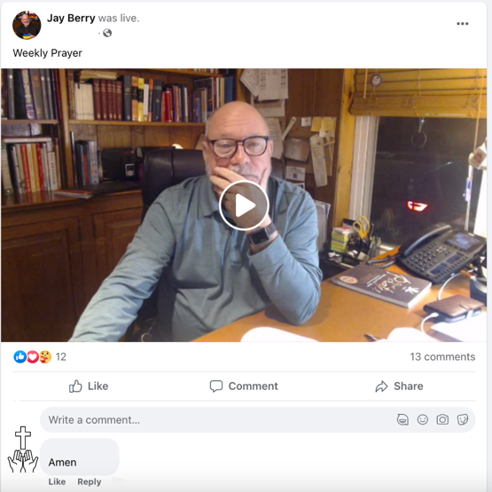
Set a day and time to go live on a social media platform (Instagram, Facebook, TikTok, YouTube, etc.). Notify people when and how they can join you for a time of prayer and reflection. When you are live, you might read scripture, a poem, a short story, then do a short reflection. After the reflection, pray intercessory prayers and ask people to enter their prayer requests in the comments or chat.

If social media isn’t for you, pick a time and invite people to join you at that specific time to pray – set an alarm to remind you!

Join the NJ Synod in prayer together every day at noon!

Prayer Around the Block
Pick a public location in the community and gather a group together to pray. It could be in a park, walking through the neighborhood, the bus stop, or even at the clock tower. Pray for the community and all that relates to the location you’re in.

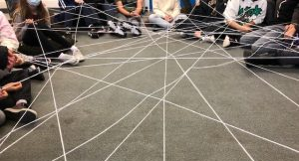
Yarn-Web Prayer
Sit in a circle with a large ball of yarn. Have one person hold the end of the yarn and say something for which they are thankful or a prayer concern. Pass (or gently toss) the ball of yarn across the circle for the next person to hold and to do the same. Continue passing the yarn, creating a web connecting the prayers together. When finished, pray the Lord’s Prayer Together.

High, Lows, God Moments
At the beginning of a meeting or gathering, take a couple of minutes for people to share highs, lows, and God moments from their past week. When finished, take time to pray either as a whole group lead by one person or break up into pairs to pray together.
Also called: Pits and Peaks or Happy and Crappy

Lectio Divina – Dwelling in the Word
This can be done on your own but can also be really fruitful when done in a group. Open yourself up to scripture to see how God is inviting you to pray.
- Read the text and sit with it in silence for a minute
- Think about the following questions: What caught your attention. What word or phrase stands out to you?
- Read the text again and sit in silence for a minute
- Think about the following question: What are you hearing in the text? What question would you ask? What
- Read the text for a third time and sit in silence
- Think about the following question: What do you think God is saying to you in this text? What might God be inviting you to pray for?
Prayer Partners, Circle, or Group
Gather people interested in praying together. Have them pair up or select a partner to pray with. They can pray for each other together or separate. This can be done with each person knowing who they are praying for or it can be done anonymously, as desired.

Prayer Team
Gather a group of seven (7) people willing to pray one day per week. Invite others to submit their prayer requests to the team (either anonymous or not). Distribute prayer requests and have one member of the team pray each day. The team may pray on their own or together or gather periodically to check in with one another on how the prayer ministry is doing.

Prayer Team or Intercessory Prayer Ministry
Gather seven (7) individuals who will pray for specific, confidential prayer requests each day of the week (one person per day). Create a space where folks can deposit their prayer requests to the team. Have a team leader distribute those requests to team members only and then pray those prayer requests on their assigned day.

Prayers for the Sirens
When you hear sirens (in a group, meeting, worship, etc.), take a moment to stop and pray. Pray for those who need help as well as those who are providing help and assistance.

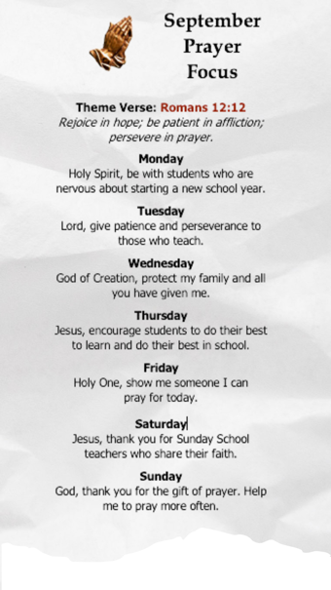
Prayer Focus Card
Using a piece of cardstock, divided into 3 columns, chose a theme verse and select prayer topics for each day of the week. Give it out to people so they can pray together for the same concern each day of the month.

You can change the verse or the prayer petitions monthly, seasonally, or as often as you feel necessary.

Praying with Candles
During a designated hymn, invite people to come forward to light candles while they pray. This works best by using bowls of sand where candles can be lit and placed in the sand or by having tealight candles in holders available.

Prayer at night in the sanctuary
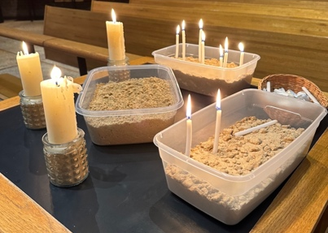
Go into the sanctuary around midnight to pray. The only lights came from the lit candles. It was powerful to pray in the dark seeing the moon shine through the stained glass.

Praying with Fire
During worship, invite people to write down their sins, regrets, joys, concerns, and prayer requests on slips of paper. At the designated point in the service people are invited to come forward, and drop their slips of paper in a basket at the foot of the cross. Burn the prayers during the service or save them to burn at a special time (with palms for Ash Wednesday, to light the Paschal Candle at the Easter Vigil, or during a summer campfire).
Let my prayer rise up, like incense before you – ELW 232

Prayer Stations or Laying on of Hands
During worship, have a designated person(s) to pray for individuals. This can be done as a station in communion or at a separate time. Invite people to come forward to receive prayer for specific requests or in general. If desired, add an element of touch (laying on of hands, hand on head, holding hands, etc.).

Blessing All the Things!
A great way to connect faith and everyday life is to bless ordinary things that make a difference in our lives. As a worshipping community bless donations to the food pantry, keychains for new drivers, or even the tools used to fix up the property.

Go And…! Planning Team Contact Information

Rev. Maristela Freiberg
Director of Evangelical Mission, NJ Synod
maristela.freiberg@elca.org

Rev. Courtney Smith Westerlund, Messiah, Oakland
pastorcourtneys@gmail.com

Rev. Danielle McCleary, St. Matthew, Secaucus
stmattsecpastor@gmail.com

Rev. Dianne Lewis, Trinity, Jersey City
pastordianne@trinityjerseycity.com

Rev. Jay Berry, St. Mark, Oaklyn
pastor@stmarksoaklyn.com

Rev. Jill Collict, Faith Lutheran, Hillsborough
pastorcollict@verizon.net

Rev. Joseph Graumann, St. Stephen, Woodbury
pastor@ststephenselca.org
Rev. Judy Anderson, St. Thomas, Brick
pastorjudystthomasnj@gmail.com

Rev. Menzi Nkambule, St. Matthew, Jersey City
pastor.stmatthewsjc@gmail.com

Lois Parrett, Abiding Presence, Ewing
lparrett@njsynod.org

